G42-200 Starliner

###### The G42-200 is a state-of-the-art aircraft capable of accelerating out of the atmosphere and into low earth orbit - Categorized as a spaceplane, the G42 features airliner-like handling characteristics, which makes it optimal for low-cost space travel and cargo lifting based on conventional or mildly adapted airfields at a fraction of the costs usually associated with space operations.

###### Fitted with a set of two RT66 Turbo-Rocket Hybrid cycle jet engines, and the ground-breaking RAMCASTER ram/scramjet system, the G42 can reach orbital velocity by simply flying out of the atmosphere, ascending as an airplane relying on its wings for lift, ultimately firing its engines in pure-rocket mode for a final boost towards orbit.

## Requirements & Installation

In order to enable cargo management and sound support, you need to install [UCSO](https://www.orbithangar.com/showAddon.php?id=6f05850c-8b74-484b-a0c0-c6a908ccfe81), [XRSound](https://www.alteaaerospace.com/index-3.html), and [SoundBridge](https://www.orbithangar.com/showAddon.php?id=c4dbdf26-e2ca-4ed4-ad82-3d48fdbfc457), all available for free.

To install, simply unpack the archive file directly into the Orbiter installation folder.

## Specifications

GENERAL

|  |  |
| --- | --- |
| EMPTY MASS | 86000 KG |
| MAXIMUM BRAKING FORCE | 800 kN |
| NOSEWHEEL MAXIMUM TURNING FORCE | 300 kN |

MAIN ENGINE

|  |  |
| --- | --- |
| MAXIMUM THRUST – TURBINE MODE | 680 kN |
| MAXIMUM THRUST – REHEAT MODE | 1500 kN |
| MAXIMUM THRUST – ROCKET MODE | 1500 kN |
| MAXIMUM SPECIFIC IMPULSE – TURBINE MODE | 41500 M/S |
| MAXIMUM SPECIFIC IMPULSE – REHEAT MODE | 55000 M/S |
| MAXIMUM SPECIFIC IMPULSE – ROCKET MODE | 7800 M/S |

RAMCASTER ENGINE

|  |  |
| --- | --- |
| MAXIMUM THRUST – LOW MODE | 3500 kN |
| MAXIMUM THRUST – HIGH MODE | 3650 kN |
| MAXIMUM SPECIFIC IMPULSE – LOW MODE | 16700 M/S |
| MAXIMUM SPECIFIC IMPULSE – HIGH MODE | 32000 M/S |

OMS & APU

|  |  |
| --- | --- |
| MAXIMUM THRUST | 65.8 kN |
| MINIMUM SPECIFIC IMPULSE | 1000 M/S |
| MAXIMUM SPECIFIC IMPULSE | 6800 M/S |
| APU FLOW RATE – ONE PACK | 0.035 KG/S |

FUEL TANKS

|  |  |
| --- | --- |
| MAXIMUM MASS – MAIN TANK | 205000 KG |
| MAXIMUM MASS – OXYIDIZER TANK | 85000 KG |
| MAXIMUM MASS – ASF TANK | 16000 KG |
| OXIDIZER/FUEL RATIO | 1.15 |

**Note: For pairs, the numbers are for one engine only.**

## Cockpit Layout

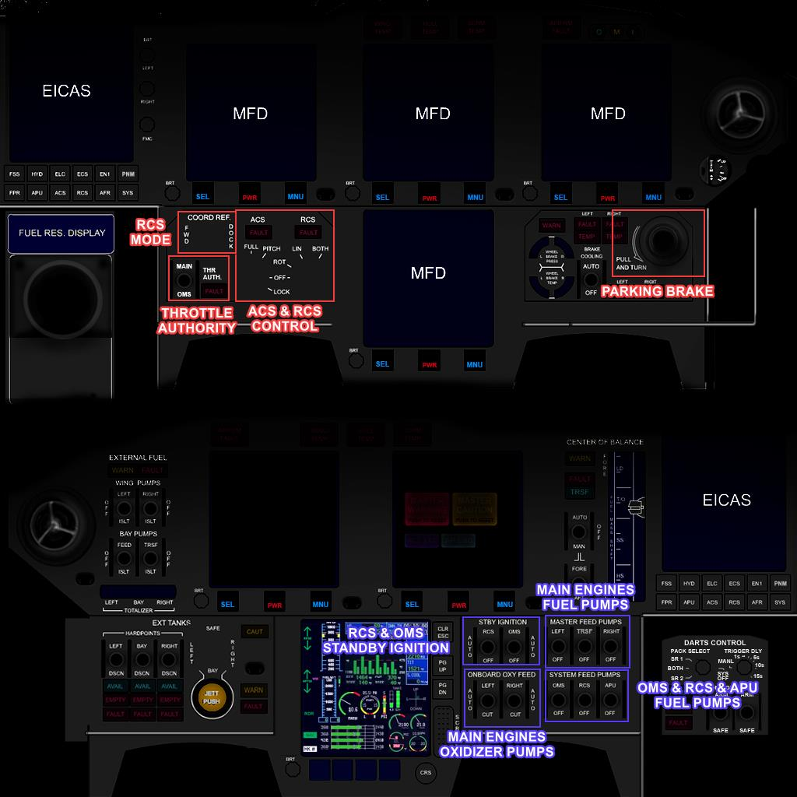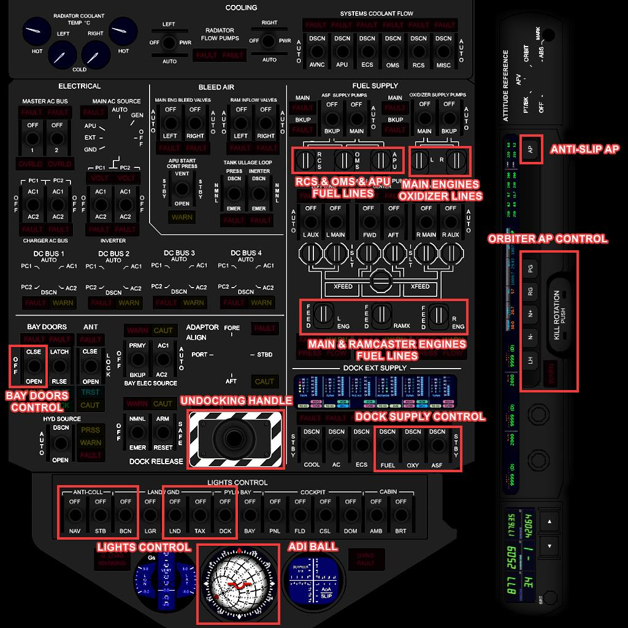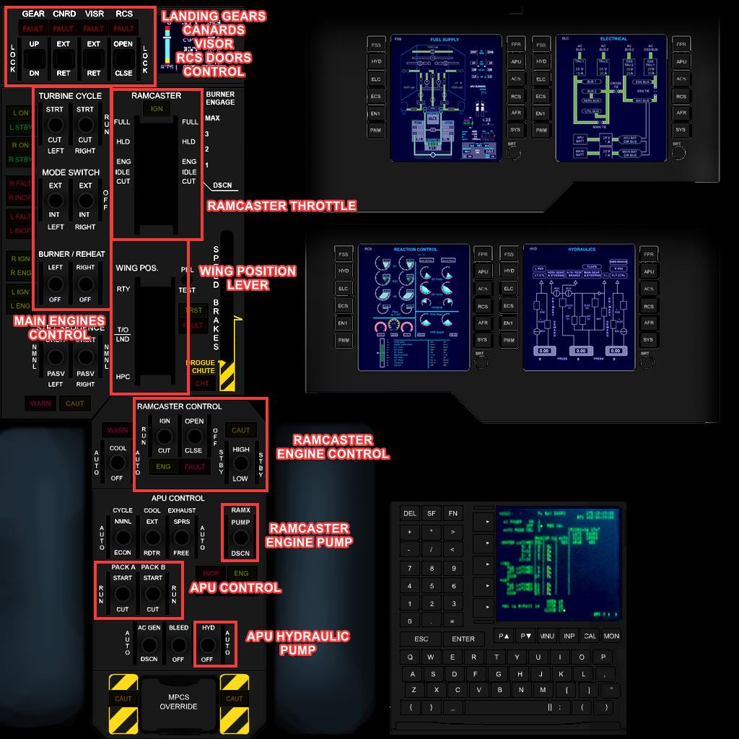

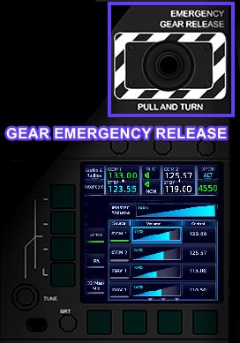

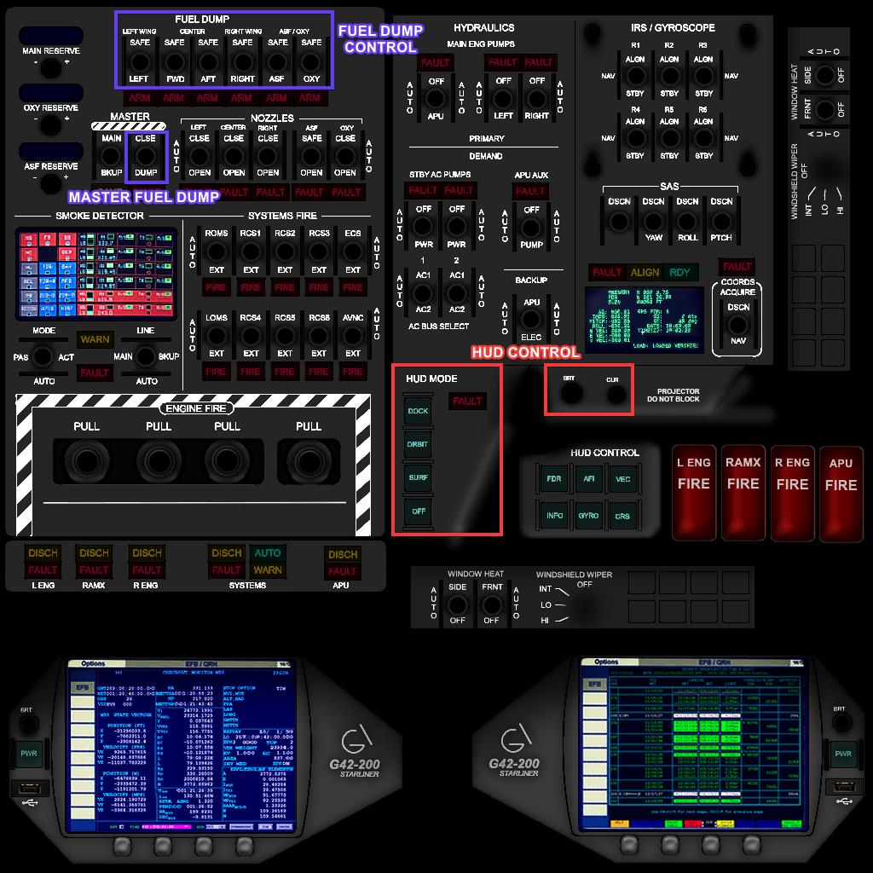

**Note: Areas highlighted in cyan are accessible from the pilot view.**

## Systems Description

Main engines

The main engines are a pair of RT-66 engine. It has 2 modes: turbine (EXT) mode, and rocket (INT) mode.

In the turbine mode, the engine uses the atmosphere oxygen to ignite the fuel. The engine efficiency depends on the spaceplane velocity and dynamic pressure. The most effective velocity and dynamic pressure are Mach 1.5 and 18K, respectively.

The turbine mode has an afterburner, which will provide up to 120% increase in thrust. Due to the high fuel consumption, it should be used only during the takeoff and certain phases in the ascent.

In the rocket mode, the engine uses the onboard oxidizer tank to ignite the fuel, so no atmospheric pressure is required. This mode should be used during orbital insertion. The oxidizer tank is designed for the orbital insertion burn, so it should be almost empty after the orbital insertion.

In this mode, the engine can’t ‘idle’, so it will shut down if the throttle is in the idle position.

The engines can be started with the TURBINE CYCLE switch. The MODE SWITCH will change the engines mode from turbine to rocket and vice versa. The mode switch will take some time.

The BURNER/REHEAT switch is used to engage the afterburner for both engines.

RAMCASTER engine

The RAMCASTER engine is a variation of ramjet engines, which depends on the spaceplane velocity to pressurize the incoming air. It has a door which must be opened to operate the engine. It has 2 modes: low mode and high mode.

The low mode is used during early ascent, where the velocity is low and the dynamic pressure is high. In this mode, the engine most effective velocity and dynamic pressure are Mach 2.5 and 16K.

The high mode is used for the rest of the ascent up to the orbital insertion, when the velocity is high enough. In this mode, the engine most effective velocity and dynamic pressure are Mach 9 and 28K.

In both modes, the engine will shut down automatically if the engine efficiency drops below 25%.

The engine can be controlled with RAMCASTER CONTROL switches. The OPEN/CLSE switch opens and closes the engine door. The IGN/CUT switch ignites and stops the engine. The HIGH/LOW switch controls the engine mode.

APU & Hydraulic

The spaceplane has 2 hydraulic system: A and B. Each system is operated with the respective APU pack.

The hydraulic system is considered operational if its pressure is higher than 2800 PSI. If the pressure is lower than 2800, the systems depending on it will become inoperative.

The systems which depend on the hydraulic system are the landing gear, control surfaces, canards, visor, RCS doors, bay doors, and RAMCASTER door. The system pressure can be monitored with the HYD EICAS screen.

The landing gears can still be extended without hydraulic pressure with the gear emergency release handle. The RCS doors must be opened to use the retro (back) translation thrusters.

There are 2 independent APU packs: pack A and pack B. Each pack operates the respective hydraulic system. The system can be monitored with the APU EICAS screen.

The APU can be controlled with APU CONTROL switches. The PACK A and PACK B switches control the APU pack. The HYD switch controls the hydraulic pump. On AUTO position, the pump will work automatically work if the APU is on.

OMS & RCS

The Orbital Maneuvering System is the primary system during orbit operations. It consists of 2 engines at the back of the spaceplane.

The OMS can be controlled with its STBY IGNITION switch, and the THR AUTH switch.

The RCS is used to control the spaceplane attitude. It consists of 22 thrusters located in various locations on the spaceplane. It has 2 modes: normal mode and docking mode.

In the docking mode, the thrusters will act as if the docking port is in the spaceplane’s front. This will greatly simplify the docking. The thrusters are also weakened by 40% to allow fine adjustments.

The RCS can be controlled by its STBY IGNITION switch and the RCS and COORD REF knobs. The latter will set the RCS mode.

PUMPS

In order for each pump to work, the fuel line of the pump must be opened, by connecting the knob line with the panel line. Each pump will shut down automatically if its tank is empty or fuel line is closed.

Each main engine has a fuel and oxidizer pump. The pumps are electrically operated.

The RAMCASTER engine fuel pump is operated by the APU. It can be activated with the RAMX switch in APU CONTROL switches.

The APU, RCS, and OMS fuel pumps are all electrically operated.

FUEL DUMP & DOCK SUPPLY

The fuel dump system will dump fuel from the spaceplane tanks, with a rate of 1980 kg/s.

The system can be controlled with FUEL DUMP switches in the overhead panel. To dump, open the valves for the tanks you want, and set the MASTER switch to DUMP.

The dock supply system will supply fuel to the spaceplane tanks when docked with another vessel, with a rate of 1020 kg/s.

The system can be controlled with DOCK EXT SUPPLY switches in the overhead panel. To supply when docked, set the corresponding switch to the tank name.

WARNING

The warning system will call out about critical situations in the spaceplane. Currently, there are 7 warnings: Low and depleted fuel warnings for all tanks, and control surface warning.

The low main fuel warning will sound if the main fuel level dropped below 42000 kg, the oxidizer warning will sound if the oxidizer dropped below 16000 kg, and the ASF warning will sound if the ASF level dropped below 3000 kg.

For all tanks, the depleted warning will sound if any tank is depleted.

The control surfaces warning will sound if the dynamic pressure is above 5K and the control surfaces are off.

All warnings can be inhibited by pressing on the master warning button.

EICAS

Currently, there are 5 operative EICAS screens: HYD, EN1, FPR, APU, and ACS.

The HYD screen displays the hydraulic system pressure in PSI. The pressure is green if it’s above 2800 PSI, and red otherwise.

The EN1 screen displays the main engines performance data.

The FPR screen displays the ascent profile and RAMCASTER engine performance data. The cyan circle represents the T1 phase, and the blue circle represents the T2 phase.

The APU screen displays the data for both APU packs.

The ACS screen displays the control surfaces position. The canards position isn’t shown if it’s retracted.

AUTOPILOT

The aircraft has the Orbiter default autopilot modes, which can be activated through buttons on the MCP, plus the anti-slip autopilot.

The anti-slip autopilot prevents slipping or skidding in atmospheric environment by adjusting the rudder to counteract the slip or skid. It’s designed to keep the slip angle within 3 degrees. The dynamic pressure must be above 7K in order for the system to work.

OTHER

There are 3 wing positions: the takeoff/landing (T/O-LND) position, the high performance cruise (HPC) position, and the reentry (RTY) position.

The T/O-LND position provides the maximum lift for velocities below Mach 3.5. The HPC position provides the maximum lift for velocities above Mach 3.5. The RTY position exposes the least amount of the spaceplane surface to heat during reentry.

The parking brake will completely stop the spaceplane when engaged. It can be set from the red handle  
from the captain seat. If the parking brake is engaged while the spaceplane is moving, full brakes will be  
applied until the plane stops.

The nose wheel can steer the spaceplane below 250 m/s. The steering performance diminishes with  
speed. Oversteering at high speeds may cause the spaceplane to flip.

The spaceplane has 6 lights: navigation, strobe, beacon, landing, taxi, and docking lights.

The spaceplane comes with UCSO support for cargo management. It can carry up to 8 UCSO cargoes in  
the bay. UCSO must be installed to enable cargo support. If not installed, install it from here.  
The slots are numbered from 1 to 8, starting directly behind the docking port towards the end of the  
bay.

## Keyboard Shortcuts

|  |  |
| --- | --- |
| Keyboard Shortcut | Action |
| Tab | Switch view to F/O - Captain |
| G | Toggle the landing gear |
| N | Toggle the canards |
| V | Toggle the visor |
| B | Toggle the bay doors |
| Shift + B | Toggle the afterburner |
| Shift + P | Toggle the parking brake |
| S | Select a cargo slot in the bay to use |
| F | Select a tank to drain fuel to from cargoes |
| D | Display cargo information in the selected slot on the HUD |
| Shift + S | Select a cargo to add |
| Shift + A | Add the selected cargo to the selected slot |
| Shift + G | Grapple the nearest cargo to the selected slot |
| Shift + R | Release the cargo in the selected slot |
| Shift + F | Drain fuel from the selected slot cargo or the nearest UCSO station to the selected tank |
| Shift + D | Delete the cargo from the selected slot |

## ***Checklists***

ENGINE START

|  |  |
| --- | --- |
| MAIN ENGINES FUEL LINES | BOTH OPEN |
| OXIDIZER LINES | BOTH OPEN |
| RAMCASTER FUEL LINE | OPEN |
| RCS & OMS & RCS FUEL LINES | ALL OPEN |
| MASTER FEED PUMPS | BOTH ON |
| APU FEED PUMP | ON |
| APU | BOTH PACKS START |
| ENGINE MODE | CHECK EXT ON EICAS |
| LIGHTS | AS REQUIRED |
| BURNER/REHEAT | OFF |
| TURBINE CYCLE | START |

TAKEOFF

|  |  |
| --- | --- |
| CANARDS | EXTENDED |
| VISOR | DOWN |
| WINGS | TAKEOFF/LANDING |
| ACS MODE | FULL |
| FLIGHT CONTROLS | CHECK ON ACS EICAS |
| PARKING BRAKE | RELEASE |
| BURNER/REHEAT | ON |
| THROTTLE | FULL POWER |
| AIRSPEED 140 M/S | V1 |
| AIRSPEED 190 M/S | ROTATE SLOWLY TO 10 DEGREES |
| POSITIVE RATE | GEARS UP, PITCH UP TO 15 DEGREES |

CLIMBOUT

|  |  |
| --- | --- |
| BURNER/REHEAT | OFF |
| ANTI-SLIP AP | ON |
| AIRSPEED | HOLD SUBSONIC |
| ALTITUDE | CLIMB TO 10 KM |

SUPERSONIC TRANSITION

|  |  |
| --- | --- |
| AIRSPEED | ABOVE MACH 0.85 |
| ALTITUDE | APPROACHING 10 KM |
| CANARDS | RETRACT |
| VISOR | EXTEND |
| BURNER/REHEAT | ON |
| THROTTLE | 80%:100% |

T1 (RAMCASTER INSERTION)

|  |  |
| --- | --- |
| FLIGHT ENVELOPE | CHECK EICAS GRAPH ON T1 |
| APU RAMX | PUMP |
| RAMCASTER DOOR | OPEN |
| RAMCASTER THROTTLE | ENG |
| BURNER/REHEAT | OFF |
| RAMCASTER | IGN, CONFIRM MODE:LO ON EICAS |
| ACCELERATION | CONFIRM INCREASED RATE |
| MAIN ENGINES THROTTLE | CLOSE |
| RAMCASTER THROTTLE | FULL |
| TURBINE CYCLE | CUT |
| MAIN ENGINES MODE | INT |
| WING POSITION | HPC AFTER MACH 3.5 |

T2 (RAMCASTER MODE TRANSITION)

|  |  |
| --- | --- |
| FLIGHT ENVELOPE | CHECK EICAS GRAPH ON T2 |
| RAMCASTER MODE | HIGH |
| RAMCASTER MODE TRANSITION | CONFIRM MODE:HI ON EICAS |
| FLIGHT ENVELOPE | PROCEED TO T3 |
| MFDs | SET AS REQUIRED |

T3 (ROCKET MODE TRANSITION)

|  |  |
| --- | --- |
| FIGHT ENVELOPE | CHECK EICAS GRAPH ON T3 |
| MAIN FUEL SUPPLY | ~80K |
| OXIDIZER FEED PUMPS | BOTH ON |
| RCS FEED PUMP | ON |
| STBY IGNITION | RCS ON |
| MAIN ENGINES THROTTLE | 25% |
| ENGINE MODE | CHECK INT ON EICAS |
| TURBINE CYCLE | START |
| GEN PCT | RISING |
| ROCKET START | CONFIRM TAPE GAUGE ON EICAS |
| RAMCASTER THROTTLE | CLOSE |
| RAMCASTER | CUT |
| APU RAMX | DSCN |
| RAMCASTER FUEL LINE | CLOSE |
| MAIN ENGINES THROTTLE | FULL |
| RCS MODE | ROTATION |
| ORBIT PROGRESS | MONITOR |

ORBIT INSERTION

|  |  |
| --- | --- |
| HUD | ORBIT |
| ApA | AS REQUIRED |
| APA REACHED | CHECK |
| THROTTLE | CLOSED, ENGINES WILL SHUT DOWN |
| TURBINE CYCLE | CUT |
| MASTER FEED PUMPS | BOTH OFF |
| MAIN ENGINES FUEL LINES | BOTH CLOSE |
| OXIDIZER FEED PUMPS | BOTH OFF |
| OXIDIZER FUEL LINES | BOTH CLOSE |
| ApA/ApT | CHECK AND MONITOR |
| VISOR | RETRACT |
| RCS DOORS | OPEN |
| BAY DOORS | OPEN |
| APU | BOTH PACKS CUT |
| APU FEED PUMP | OFF |

ORBIT CIRCULAIZITION

|  |  |
| --- | --- |
| ApT | T-100s |
| OMS FEED PUMP | ON |
| STBY IGNITION | OMS ON |
| THR AUTHORITY | OMS |
| OMS CAPABILITY | CHECK OMS SHOWN ON HUD |
| ApT | HOLD FOR MARK AS REQUIRED |
| THROTTLE | OPEN AS REQUIRED |
| ApA/PeA/Ecc | MONITOR UNTIL OMS CUTOFF |

## Credits

[Moach](https://www.orbiter-forum.com/member.php?u=1303): original developer.

[Face](https://www.orbiter-forum.com/member.php?u=293): Orbiter 2016 support.

[dgatsoulis](https://www.orbiter-forum.com/member.php?u=3516): Meshes, textures and contrails.

## About

G42-200 Starliner is a free open-source spaceplane for Orbiter 2016, under MIT license. The source code can be found on the [GitHub repository](https://github.com/abdullah-radwan/G42-200). Any contributes are appreciated.

Copyright © Moach

Copyright © Abdullah Radwan